**Festival of Saint Medir (Feste de Sant Medir) 2022**

**Where: Plaza de Rius i Taulet, Gracia district, Barcelona,**[**Barcelona**](https://www.carnifest.com/city/barcelona/)**,**[**Spain**](https://www.carnifest.com/country/spain/)

**When:**Thursday, March 3, 2022

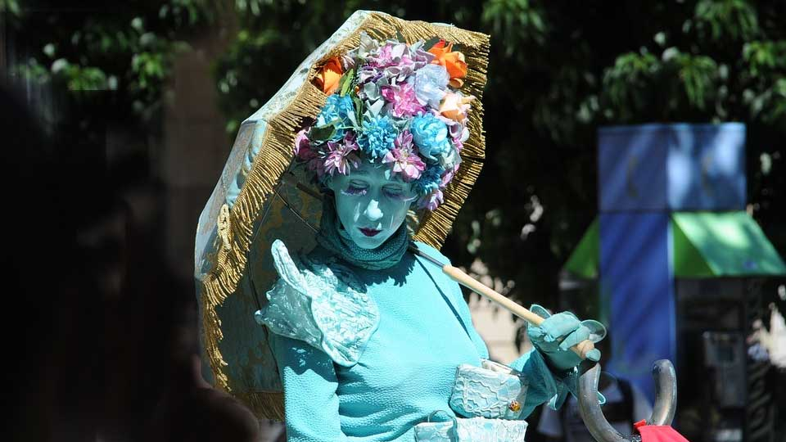

**Live Statue**

Since the 16th century, for more than four hundred years, the Festival of Saint Medir (Feste de Sant Medir) is celebrated in Barcelona on the 3rd of March.

The main event of the festival is a parade with wind instruments bands, clowns, jugglers and colorful carriages driven by representatives of the thirty suburbs of the city dressed in traditional cloth and carry flags. During their march, the carriages’ passengers throw candies on the watching crowd.

The parade ends in spectacular colorful fireworks show which paints Barcelona’s sky in multicolor.

# Sant Jordi 2022 04/23/2022

This is one of the most keenly anticipated and widely celebrated Catalan public holidays. According to the traditional tale, Sant Jordi (Saint George) killed the dragon that used to live in Montblanc where it terrorized the local population, thus saving the king's daughter from certain death. Legend has it that a beautiful rose bush sprang up in the spot where the dragon's blood was spilled. From the 18th century onward, the Sant Jordi festival became widely identified as a Catalan 'fiesta' which these days arouses great popular, civic and cultural passion. On Sant Jordi's Day, lovers exchange a rose and a book and every town and city in Catalonia is filled with stalls set up to sell both. The center of Barcelona becomes just one big open-air bookshop where you can find everything from the latest publications to renowned writers signing copies of their work.

Enjoy Catalan festival in the different neighborhoods and streets of the city!

# Barcelona Lady of Mercy Festival 2022

**Where:**[**Barcelona**](https://www.carnifest.com/city/barcelona/)**,**[**Spain**](https://www.carnifest.com/country/spain/)

**When:**Around September 24th 2022 .

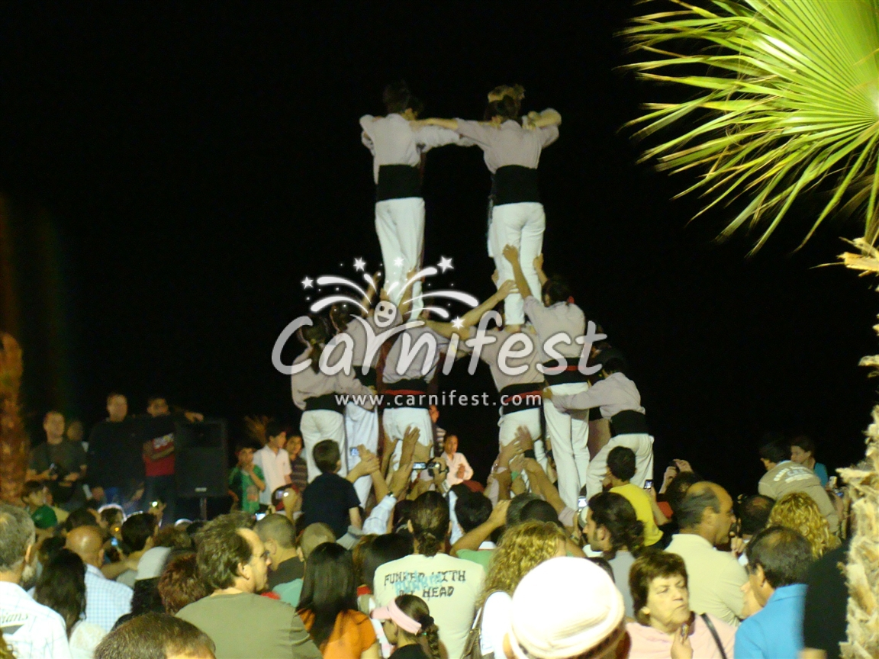

**Castellers – the human towers in Barcelona**

CarniFest Online Photo © All Rights Reserved

Las Fiestas de la Merce – Barcelona Lady of Mercy Festival is one of the great festival of Barcelona, or even the greatest. More than six hundred culture and public activities are held.

The annual fiestas symbol the end of the summer, the start of autumn and gratitude to the holly patron of Barcelona, The Lady of Mercy (La Mare de Deu de la Merce), who saved the city from a disaster of locust in 1687.

Lot of culture events are held in the open-air, dance, music, colored parades, air show, fireworks and a colorful noisy parade which cross the central streets of the city. Many more shows are added every year to the festival.  
This is a week of fiestas that can’t be missed.

Zurich Marathon in Barcelona   
05/08/2022

In its 44th edition, this race has become one of the most well-known marathons in Europe. The Zurich Marathon in Barcelona is a huge city festival where runners from around the world come and enjoy this fantastic long-distance race. They are backed by the good weather and more than 42 km of city circuit which winds through the most emblematic parts of the city. It becomes, according to its participants, one of the most spectacular race in the world.

Formula 1 Gran Premio de España   
05/20/2022 - 05/22/2022

Those loud engines are getting ready to rev once more at the Circuit de Barcelona-Catalunya. Over three days in May, Barcelona hosts the fifth event of this year's F1 Championship Season, the Spanish Grand Prix. This is undoubtedly one of the biggest dates on Barcelona's sporting calendar, and an amazing opportunity to see the celebrated drivers and teams taking part in one of the most thrilling sports in the world.

Barcelona Polo Challenge Negrita Cup   
05/13/2022 - 05/22/2022

Enjoy the spectacle of one of the world's oldest sports where speed and the relationship between the riders and the horses play an essential role. The Real Club de Polo de Barcelona will be hosting the 54th Torneig Internacional de Polo, the **Barcelona Polo Challenge** – Negrita Cup. There will be three matches every day over two consecutive weekends during which six teams of international players will vie for the trophy.